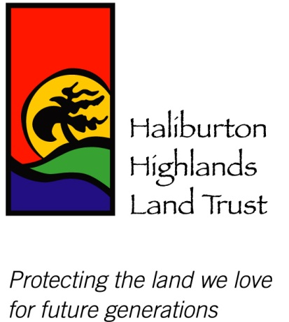

Press Release

Haliburton Highlands Land Trust Premieres “Conservation in Action”
Haliburton, ON March 3, 2022: On Thursday night, local MPP Laurie Scott and Les Kariunas, an Ontario Trillium Foundation (OTF) volunteer met online with representatives of the Haliburton Highlands Land Trust (HHLT) for the official launch of the group’s “Conservation in Action/Dahl Forest and Barnum Creek Nature Reserve” video. The video was made possible thanks to a $48,500 Resilient Communities Fund grant awarded by OTF in late 2020.

“Community engagement and education is so important to the mission of the Haliburton Highlands Land Trust and I’m glad this funding can help support local initiatives community members are passionate about in Haliburton County,” said Laurie Scott, MPP for Haliburton-Kawartha Lakes-Brock.

In addition to the new video, the OTF grant was also used to update HHLT’s website, making it more user-friendly and able to store more videos and information materials. Funds were also used to help with staffing and some administrative costs, as well as software and licenses and training too.

“The OTF/RCF funding has allowed HHLT to rebuild, recover from and adapt to the impacts of COVID-19, including the redesign of our website, improve communication and capabilities to enhance the Land Trust Discovery Days educational programs online, as well as showcase our conservation projects and our recreational properties,” said Shelley Hunt, Chair of HHLT. “We are excited to showcase our new user-friendly website, which will be home to all of our environmental resources and videos, including “Conservation in Action/Dahl Forest and Barnum Creek Nature Reserve,” added Hunt.

The Haliburton Highlands Land Trust thanks the Ontario Trillium Foundation for its continued support. HHLT is a not-for-profit, non-governmental, registered environmental charity that was established in 2005. It is dedicated to conserving the natural environment and enhancing quality of life in the Haliburton Highlands. HHLT’s work is focused on private land conservation and complements the mandates and activities of other organizations and agencies in the area, including municipal, provincial and federal governments, conservation authorities and other NGOs. HHLT focuses its efforts on three main activities: the acquisition of ecologically sensitive land, education and research, and owns, manages and protects five properties in Haliburton County, representing approximately 1,300 acres.

The Ontario Trillium Foundation (OTF) is an agency of the Government of Ontario, and one of Canada’s leading granting foundations. Last year, nearly $112M was invested into 1,384 community projects and partnerships to build healthy and vibrant communities and strengthen the impact of Ontario’s non-profit sector. In 2020/21, OTF supported Ontario’s economic recovery by helping non-profit organizations rebuild and recover from the impacts of COVID-19. Visit otf.ca to learn more
-30-
For more information, please contact:
Sheila Ziman, Board Director Christel Furniss
Haliburton Highlands Land Trust Haliburton Highlands Land Trust
705-457-0455 admin@haliburtonlandtrust.ca

